**•init**

-The git init command is used for creates a new repository.

-Screenshot .png

-syntax:

“Git init”

•add

-The git command adds a change in the working directory to the staging area.

Screenshot 2024-06-01 113614.png

-syntax :

“git add”

**•status**

-The git status command display the state of the working directory and the staging area.

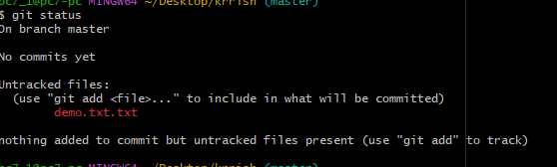

-syntax:

“git status”